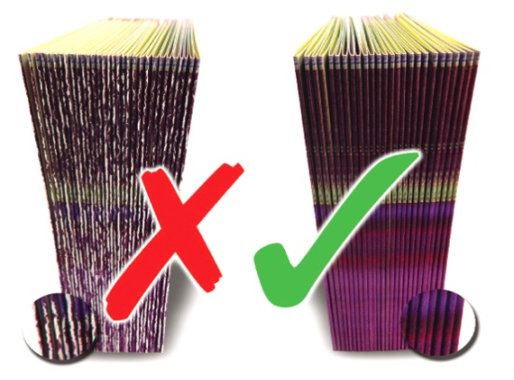

BOOK YOUR FREE DEMONSTRATION NOW
and pay nothing for our unique finishing accessory worth £50
- Is fibre cracking a constant threat to your folding, stitching and binding work?

- Do you feel let down by inadequate scoring, cutting and perforating tools that give poor results, time and time again?
We guarantee to eliminate all of these problems using our new patented devices.
Call 01455 554491
www.technifold.com
Tel: 01455 554491 Fax: 01455 554526 Email: lee.white@technifold.co.uk
Tech-ni-Fold, Unit 2, St John’s Business Park, Lutterworth, Leicestershire, LE17 4HB, UK

